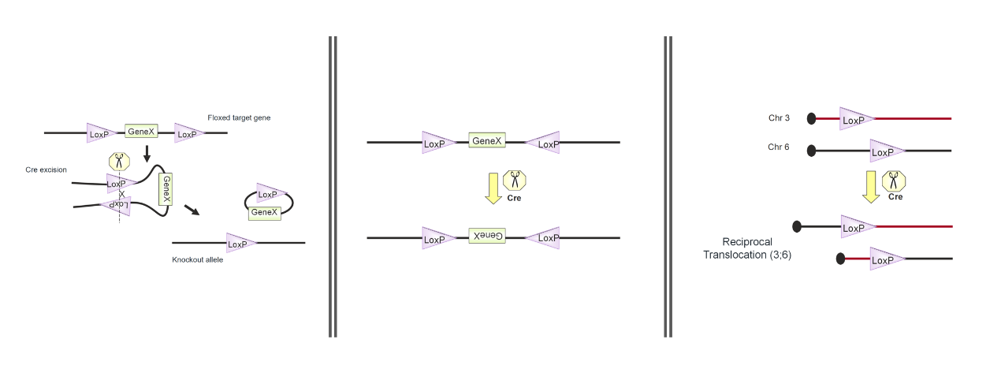

http://2017.igem.org/wiki/images/c/cb/Tud1.png

Fig. 3.1 The left : when the <i>loxp</i> sites are in same orientation, this gene will be deleted.The middle : when the <i>loxp</i> sites are in opposite orientations, this gene will be inversed.The right : when the <i>loxp</i> sites are on different chromosomes, the gene will be exchanged.

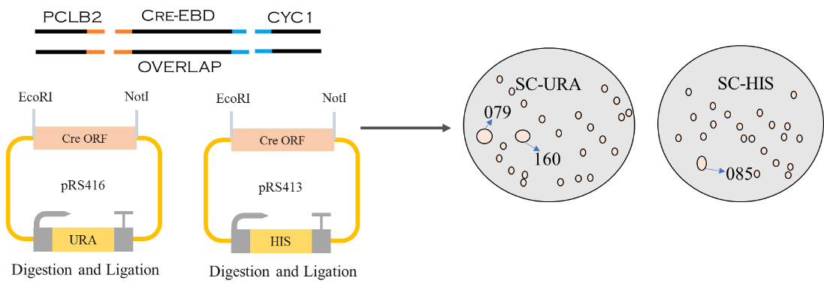

http://2017.igem.org/wiki/images/c/c2/Tud2.png

Fig. 3.2 Construction process

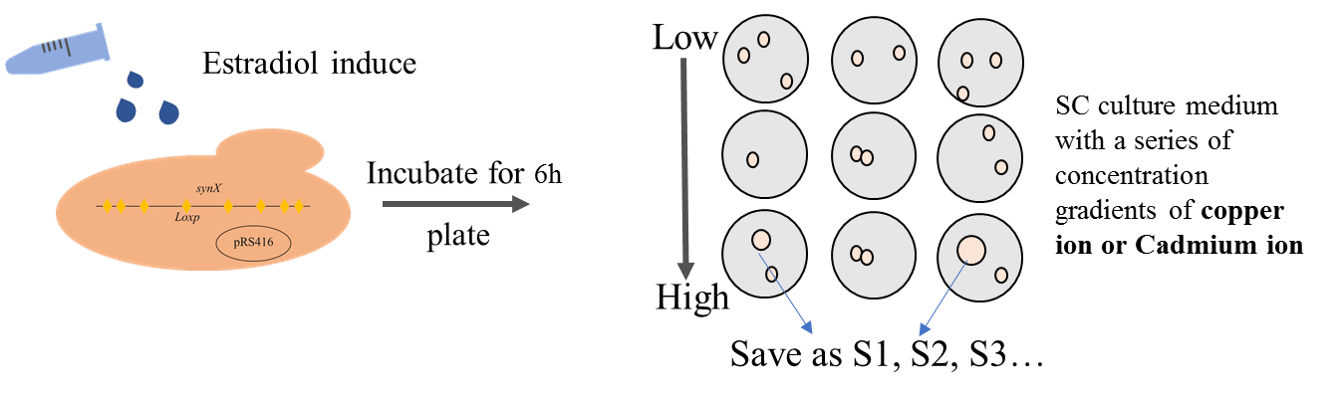

http://2017.igem.org/wiki/images/0/08/Tud3.png

Fig. 3.3 Screening of Strains (Take 160 as an example)

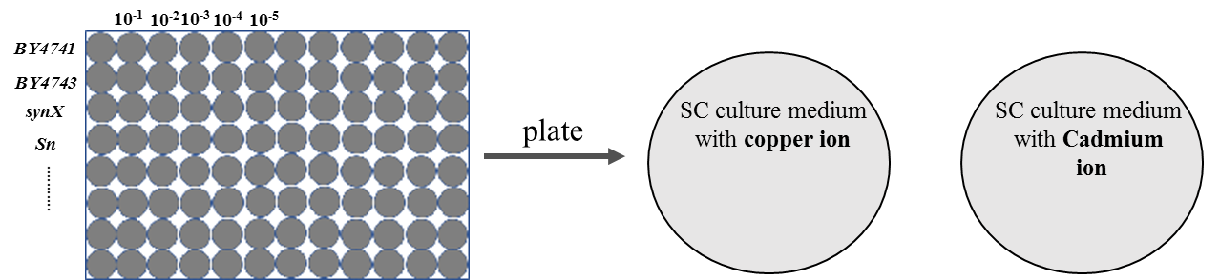

http://2017.igem.org/wiki/images/a/ab/Tud4.png

Fig. 3.4 Dilution assay

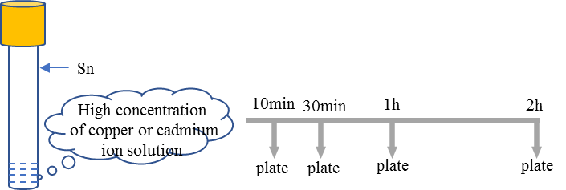

http://2017.igem.org/wiki/images/0/00/Tud5.png

Fig. 3.5 Measurement of cell survival rate